We’re Back!
Nearly 500 friends of the McArthur-Burney Falls Interpretive Association have subscrribed to our newsletter in the past. The ‘quarterly’ newsletter from MBFIA has been sporadic in recent years. We plan to revivie this tradtion and do our best to stick to a quarterly schedule. This newsletter is scheduled for early April and you can expect to see the next one in early July as America celebrates the Semiquincentennial of the signing of our Declaration of Independence. In the October newsletter we will look forward to Heritage day. And to finish the year, the January 2027 newsletter will start the Centennial celebration of the McArthur-Burney Falls Memorial State Park.

Upcoming Dates in 2026
- April 1 – Seasonal openings begin.
- Friday, April 3 – Visitor Center and Store open
- Sunday, April 5 – Easter
- Friday, May 1 – Season opens at the Falls
- Friday, May 15 – Reserved camping starts
- Friday, May 22-Sunday, May 24 – Memorial Day Weekend (Warning: Very busy roads.)
- Monday, May 25 – Memorial Day (adjusted)

- Saturday, July 4 – 250th Anniversary Independence Day
- Monday, September 7 – Labor Day
- Saturday, September 12 – MBFIA Volunteer Appreciation Day & Lunch
- Sunday, October 11 – McArthur-Burney Falls Heritage Day Celebration
- Monday, October 12 – Columbus Day
- October 31 – Most seasonal facilities close
- Wednesday, November 11 – Veterans Day
- Thursday, November 26 – Thanksgiving
- Friday, December 25 – Christmas
- Friday, January 1, 2027 – New Years Day

About MBFIA
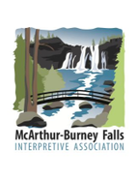
The McArthur Burney Falls Interpretive Association (MBFIA) is an all-volunteer non-profit education organization that provides assistance and funding for activities which enhance the quality of visits to McArthur Burney Falls Memorial State Park, Castle Crags State Park and Ahjumawi Lava Springs State Park. The association was founded in 1984 to promote greater appreciation of the cultural and natural history of the region.
Table of Contents
Welcome Back! 1
Upcoming Dates in 2026 1
About MBFIA 1
Donations 3
Board Members 3
Firewood at the Falls 3
Mission 3
President’s Message 4
2026 MBFIA Annual Plan 4
Board Meeting Highlights 6
A Wonder of the World 11
About the Three State Parks 11
McArthur-Burney Falls Memorial State Park 11
Castle Crags State Park 12
Ahjumawi Lava Springs State Park 13
Meet 13
The Newsletter Editor Tony Otto 13
Falls Visitor Center 13
Visitor Center Store 14
Featured Artist this Quarter: 14
Burney Falls General Store 15
Job Openings 15
MBFIA Bookkeeper 15
Camp Hosts 15
Visitor Services Senior Park Aide 15
Memorial Tables 16
Tribute 16
A Tribute to Generations of Families Who Vacation At Burney Falls 16
Tribute to Families that call McArthur Burney Falls Home 17
Friends of the Falls 17
Contact Infomation 18
On the Internet 18
MBFIA (McArthur-Burney Falls Interpretive Association) 18
Burney Falls General Store 19
MacArthur-Burney Memorial State Park 19
Castle Crags State Park 19
Ahjumawi Lava Springs State Park 20
April Featured Artist: Marla Nolan 20
Secret San Francisco Article 21

Donations
We are a group of volunteers who love and support our northern California State Parks. We operate gift shops, sell firewood and do other fund-raisers to help us help the parks!
All donations are used for educational and interpretive activities in the Park.
Did you enjoy the campfire and evening programs? These are supported by donations.
Did you or your child complete the Discovery Quest Challenge? The patch you received was paid for with donations.
Did you take a nature walk or a guided canoe trip on Lake Britten? These are supported by donations.
Is this Visitor Guide newspaper helpful and interesting? Donations paid for printing the paper.
Did you attend Heritage Day? Donations provide candle-making, beading, saw-bucking, rope-making, pine-doll building, apple cider press, and old time fiddle music. This celebration of life in the Intermountain Area in the 1870’s is provided thanks to donations.
Donations for the Park are accepted by the McArthur-Burney Falls Interpretive Association. An organization of volunteers from the communities around the Park, the Association is also known as the Friends of the Falls. We love the Park and we know that you do as well.
We encourage every visitor to make a donation in any amount to support activities in the Park. Checks may be made payable to MBFIA, Box 777, Burney CA 96013. Donation envelopes are available in the kiosk at the entrance or in the Visitor Center. We will list donors in next year’s Visitor Guide.

Board Members
- President Jim Sacson
- Vice President: Mark Downie
- Secretary: Ann Sacson
- Treasurer Emiritus: Jaci White
- Webmaster: Bob Boyce
- Tablemaster: Bill McSweeney
- Media Rep: Craig Harrington
- Newsletter Editor: Tony Otto
- Volunteer: Susan Lamke
- Alice Hoveman
- Jill Overbaugh
- Tom Stockton

Firewood at the Falls
The MFBIA has firewood in 0.8 cubic foot bags available just past the entrance kiosk and at the upper and lower campground areas when open. The cost is $10/one bag, $18/two bags, and $25/three bags.

Where does the Firewood Come From?
What would camping be without a campfire, and those marshmallows! Have you wondered where that nicely bagged wood comes from?
To start with, the wood itself comes from right here in the Park. We want to be sure that firewood does not bring in pests and diseases from out of the area. When trees die, are felled by storm or fire, or are cut down as hazards, the wood is cut and bagged in manageable amounts by inmates housed at the Intermountain Conservation Camp, managed by CalFire. These hard workers also do some of the hazard tree removal, trail repair, campground clean-up, weed eating and brushing, both here in Burney Falls and in Ahjumawi Lava Springs State Park. Their efforts supplement the hard work of the Park’s maintenance staff, MBFIA volunteers who replenish the wood sheds weekly, and save taxpayer funds.
On top of supporting a healthy forest, these efforts produce a significant portion of the proceeds each year for the McArthur Burney Falls Interpretive Association in support of campfire and evening programs, replacement of interpretive signs that have weathered dramatically in the last 10 years, bird and nature walks, the Discovery Quest and Junior Ranger programs, Heritage Day, other interpretive programs for young and old, including the production of the Visitor Guide.

MBFIA Mission Statement
The McArthur Burney Falls Interpretive Association is an all-volunteer non-profit education organization that provides assistance and funding for activities which enhance the quality of visits to McArthur Burney Falls Memorial State Park, Castle Crags State Park and Ahjumawi Lava Springs State Park. The association was founded in 1984 to promote greater appreciation of the cultural and natural history of the region.
MBFIA raises funds to support educational and interpretive activities, including interpretive personnel, and a printed Visitor Guide provided free to visitors. MBFIA manages the Visitor Center Gift Shop. Funds are raised through the sale of firewood, advertising in the Visitor Guide, the operation of the Visitor Center gift shop, and most importantly, donations from friends and visitors.

Friends of the Falls
Friends of Burney Falls provides education and interpretation and our programs highlight the Park's natural and cultural elements. Burney Falls offers hiking trails, flora and fauna, birds, squirrels and the like, camping, cabins and Lake Britton. Funds donated support Interpretive and educational activities, including guided hikes, Junior Ranger programs, campfire and craft activities, sing-alongs and group games. At Burney Falls, our Visitor Center includes a Gift Shop, as well as information about the geology, flora and fauna, cultural history and recreational opportunities in the park and the surrounding area. Our annual Heritage Day celebration in October offers weaving, cross-cut sawing, branding, candle-making, pine-doll making, apple cider pressing and Dutch Oven cooking. The Park has instituted a birding program, that includes guided bird identification walks, loaner binoculars plus a library of information. In addition, we have supported new native plants around the Visitor Center, with information about the plantings available for visitors.
We're also in the process of renewing our availability for sale and placement of memorial benches and picnic tables at the Park. Contact us for more details.

President’s Message
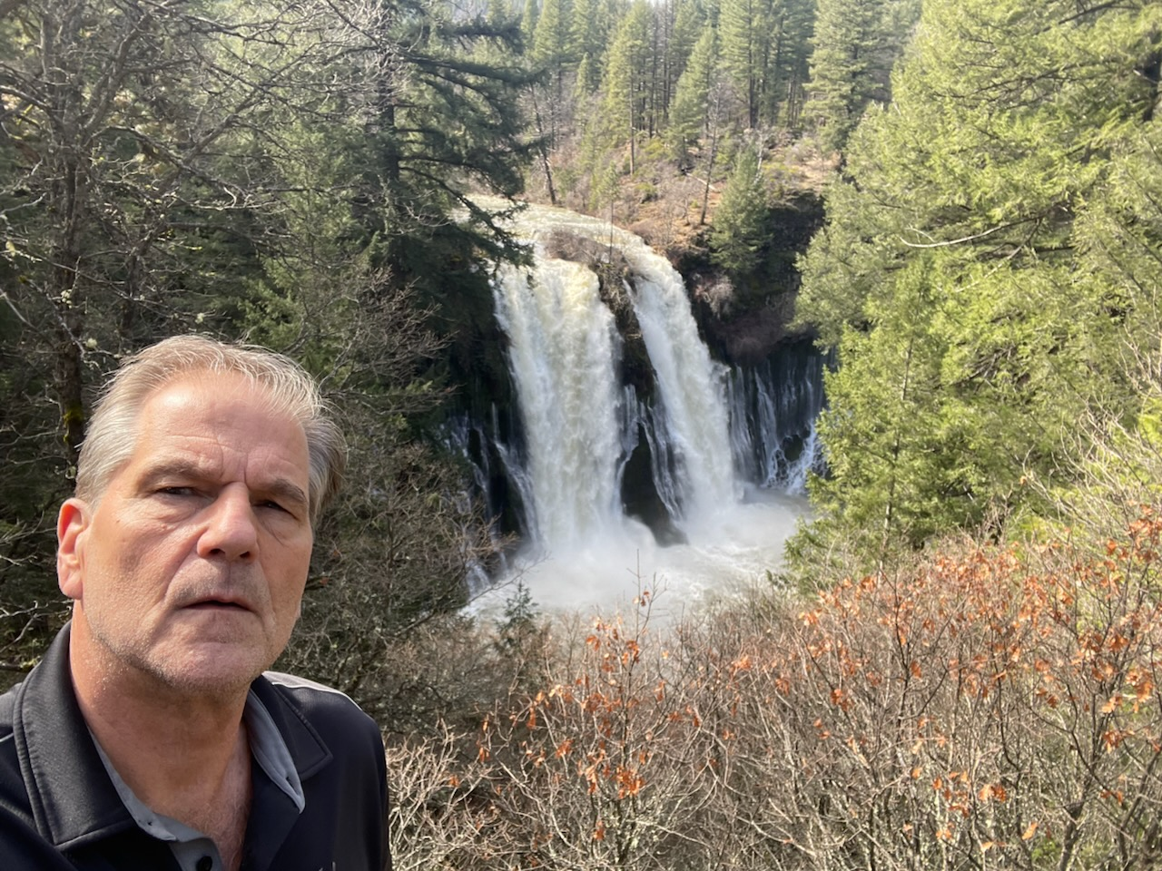
As President of the McArthur Burney Falls Interpretative Association, I am pleased to welcome visitors to the McArthur-Burney Falls Memorial State Park. In 1964, my family bought a home and property near the park. I had the tremendous opportunity of growing up here. My family enjoyed exploring the natural beauty and all of the outdoor activities the Intermountain area has to offer.
I served in the United States Navy after high school and had the privilege of traveling to many places around the world. My travels helped me appreciate how unique and untouched much of our mountain area has remained. It is my desire to help retain the natural beauty we get to enjoy every day.

Board Meeting Highlights

January 2026
- The association budget for 2026 will mirror 2025.
- Hamburgers and hotdogs will be used for Volunteer Appreciation Day and Heritage Day.
- Typically 6,000 firewood bags are used per season.
- No Memorial Picnic Tables were sold in 2025. There is one family interested at this time. There is continued interest in benches.
- Volunteer Day was set for Saturday, September 12, 2026. Heritage Day will be Sunday, October 11.
- Planning for replacing technical equipment and updating the video for the Visitor Center.
- Fair weather is keeping the Parks busy prior to the traditional season. The same staffing level for is very optimistic for this year.
- The MBFIA will continue to fund additional signage.
- Old stands or signage might be desirable to purchase by visitors or supporters of the Park.
- The cost and beauty of the new signage has been disappointing due to the finished artwork not being installed quickly and properly.
- Tony Otto was approved as a new board member.

February 2026
- 2026 is not appropriate for a Centenial celebration. In 1927 there was a Bill put forward and passed that turned Burney Falls land into a State Park. The land was transferred to the State in 1923.
- We will recognize the 250th anniversary of the United States during Heritage Day.
- Memorial Day will continue to be challenging due to high demand for camping.
- Once the Castle Crags signage is installed, the Burney Falls signage will be completed.
- Advertising in the local paper & posting on bulletin boards was suggested to recruit new members.
- The association will continue to manage recycling.
- T-shirts were okayed by Parks for this year. Other ideas for using the same artwork will be pursued.
- The Visitors Center will open as soon as possible, targeting April 3, with staffing Tuesday through Sunday.

March 2026
- The current slate of officers was approved for 2026.
- A paid seasonal non-profit treasurer may be hired.
- Volunteer flyer posters will be placed at key businesses and bulletin boards in the region.
- Hopefully this newsletter will bring more interest in Memorial Tables. Ed. Note: See the Memorial Tables section above for details.
- Firewood sales may be banned if the State declares a dry, hot season. The park staff will lock the sheds if required to do so.
- QR codes to be included in the newsletter was suggested. Ed. Note: QR codes are included with the web links at the end of this newsletter.
- Tony asked board members to submit items to add to our newsletter.
- The association is considring a Volunteer of the Year on Heritage Day.
- Jaci let us know the T-shirts were in. Pictures will be included in this newsletter. Ed. Note: See Visitor Center Store below.

A Wonder of the World
SecretSanFrancisco.com recently posted an article about Burney Falls. Whether future President Teddy Roosevelt described it as the ‘Eighth’ or just ‘A’ Wonder of the world is up to interpretation, the falls are certainly wonderous. Ed Note: See the On the Internet section at the end for a link.

About the Three State Parks

McArthur-Burney Falls Memorial State Park
The park is within the Cascade Range and Modoc Plateau natural region, with forest and five miles of streamside and lake shoreline, including a portion of Lake Britton.
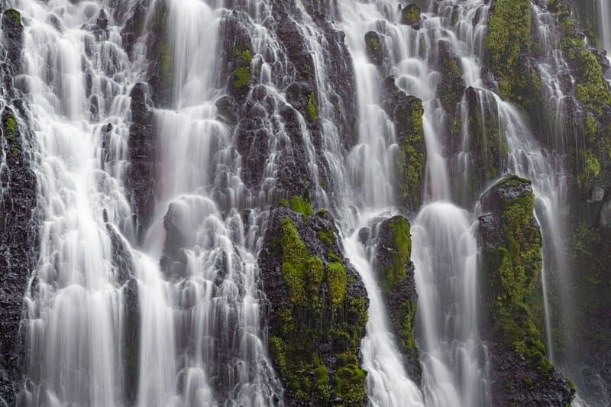Courtesy CA State Parks
The park's centerpiece is the 129-foot Burney Falls, which is not the highest or largest waterfall in the state, but possibly the most beautiful. Additional water comes from springs, joining to create a mist-filled basin. Burney Creek originates from the park's underground springs and flows to Lake Britton, getting larger along the way to the majestic falls.
The park's landscape was created by volcanic activity as well as erosion from weather and streams. This volcanic region is surrounded by mountain peaks and is covered by black volcanic rock, or basalt. Created over a million years ago, the layered, porous basalt retains rainwater and snow melt, which forms a large underground reservoir. Within the park, the water emerges as springs at and above Burney Falls, where it flows at 100 million gallons each day. Burney Falls was named after pioneer settler Samuel Burney who lived in the area in the 1850s. The McArthurs were pioneer settlers who arrived in the late 1800s. Descendants were responsible for saving the waterfall and nearby land from development. They bought the property and gave it to the state as a gift in the 1920s. This year, we experienced heavy snow in mid-February so the falls were flowing exeptionally heavy.
Cellular service in the park continues to improve, so you should be able to find a signal as you travel the roads.

Visitor Information for the Falls:
McArthur Burney Falls Memorial State Park entrance kiosk is open now, but closed in the off-season. Please bring exact change or credit/debit cards to pay by APM (Automatic Payment Machine) which is located just pass the entrance kiosk in front of the visitor center.
- Park Day-Use Fee - $10 Per Vehicle
- Overnight Camping - $35 Per Night (Includes One Vehicle).
- Additional Overnight Camping Vehicles - $10 Per night.

Warnings for Falls Vistors:
McArthur Burney Falls State Park experiences extremely high visitation beginning in April and continuing through October. Most weekends all summer the park will fill to capacity and entrance into the park is subject to closure due to limited parking availability. Visitors should expect traffic delays on State Highway 89 for up to an hour prior to entering the park due to the increased visitation experienced at this park. It is illegal to park along Highway 89 outside of the park for a mile either direction. If you park along Highway 89 your vehicle will be subject to citation and tow. The speed limit is 55 mph along Highway 89 and utilized by a large volume of semitrucks, it is not recommended to walk along the highway. If you arrive to find the entrance closed due to full capacity, please return at a later time - typically after 4:00 p.m.
The park cannot admit entrance to vehicles over 32 feet for day-use or camping. Additionally, only a limited number of oversized vehicles (less than 32 feet in length) will be admitted into park. Oversized vehicles will only be allowed to park in the Lake Britton parking lot (approximately 1.5 miles walk to the falls) on Fridays, Saturdays, and Sundays.
Due to limited parking capacity, McArthur-Burney Falls Memorial State Park cannot accommodate entry, drop-offs or parking of tour busses until further notice.

Castle Crags State Park
Majestic Castle Crags have inspired enduring myths and legends. More than 170 million years old, these 6000-feet tall granite spires in the Castle Crags Wilderness border the northwestern edge of Castle Crags State Park.

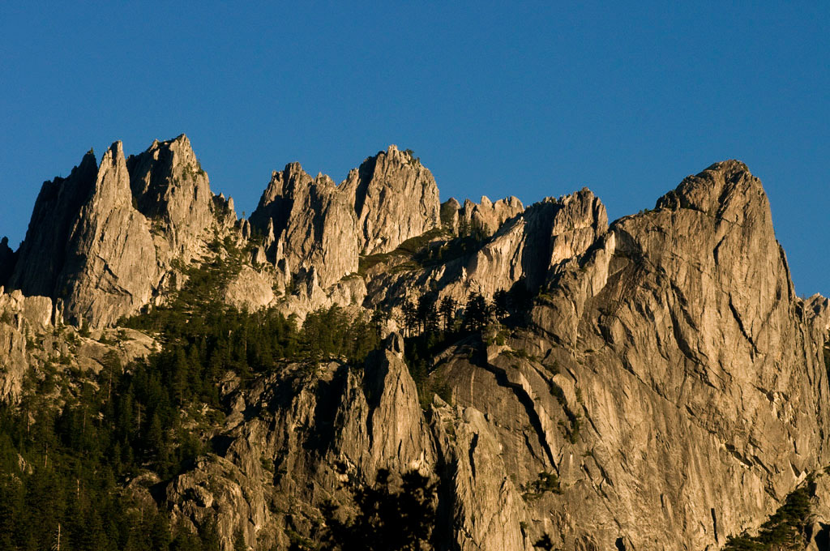Courtesy of California State Parks, 2026.
Castle Crags State Park offers a variety of camping, picnicking, hiking, and fishing opportunities.
The park has 76 developed campsites that are each equipped with a picnic table, food locker, and a fire ring. Flush toilets, showers, and drinking water are available near each campsite. Picnic sites are located along the Sacramento River and at the awe-inspiring Vista Point.McArthur Burney Falls State Park experiences extremely high visitation beginning in April and continuing through October. Most weekends all summer the park will fill to capacity and entrance into the park is subject to closure due to limited parking availability. Visitors should expect traffic With 28 miles of hiking trails, everyone can enjoy a mild stroll or an invigorating adventure. From the Vista Point parking area, a quarter mile accessible trail leads visitors to Vista Point where there are dramatic views of Castle Crags, Mount Shasta, and nearby Grays Rocks. Gentle and shaded, the mile long Root Creek Trail guides hikers along an accessible path to a year round flowing creek.
The most popular and challenging route is the Crags Trail which leads adventures to the base of Castle Dome where the views are simply breathtaking. The Pacific Crest Trail winds through the Park as well. Castle Crags State Park is often a respite for the weary hikers of this 2,650 mile trek from Mexico to Canada.
The Sacramento River flows through the park and has several access points that allow for fishing and hiking. Facilities at Riverside include camping and picnicking sites as well the famed pedestrian suspension bridge that crosses the Sacramento River.

Ahjumawi Lava Springs State Park
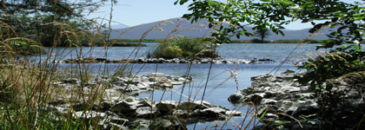
"Where the waters come together...." is a translation of the California Indian word Ahjumawi, which is also the self describing word used by the band of Pit River of Indians who still inhabit the area.
Ahjumawi is a place of exceptional, even primeval, beauty. Brilliant aqua bays and tree studded islets only a few yards long dot the shoreline of Ja-She Creek, Crystal Springs, and Horr Pond. Over two thirds of the area is covered by recent (three to five thousand years) lava flows including vast areas of jagged black basalt.
The park's backcountry is charactarized as wilderness with extremely rugged lava rock. Visitors should prepare adequately for their visit. While there are over twenty miles of park trails by which to explore this beautiful geographical wonder, please be advised that travel off the trails requires proper preparation and equipment. Be sure someone knows where you are going and when you expect to return.

Meet

The Newsletter Editor Tony Otto
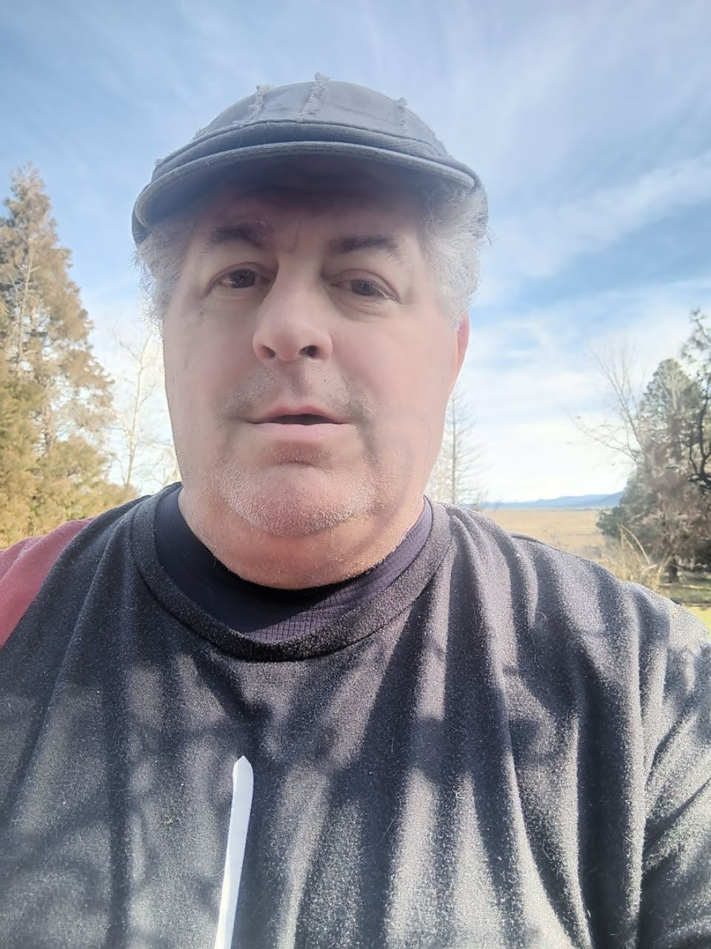
I visited the falls and nearby Lassen park during summer vacation a couple of times as a primary grade schooler and as a junior high student. Those were great memories, along with coming around a curve on CA-299 and coming upon a VW Beetle sized boulder that had fallen on the upward lane of the highway. I’m not sure my Dad was as amused as I was. Fifty plus years later, the opportuntity to live in Fall River Mills came about. Now I live a few short miles from the falls. I was asked to join the Board of Directors of the MBFIA and I greatfully accepted. When the need to resume the quarterly newsletter arose, I willingly took on the challenge.

Falls Visitor Center
The MBFIA operates the visitors center at the main parking lot above the falls. There you will find informative panels about the , the park, and the local flora & fauna. Several art exhibits are displayed in the center, including: Ed. Note: See this quarter’s featured artist below.

Visitor Center Store
The 2026 T-Shirts are now available at the Visitor Center Store.
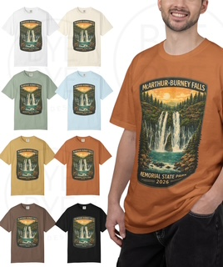
At the center, you will find these items for sale:
- Water Bottles and Mugs
- Stuffed Birds that frequent the park
- Patches and Badges
- Magnets and Pins
- Camping supplies
- Walking Sticks
- T Shirts with color print of McArthur Burney Falls
- Hats
- Sweatshirts
- Guides to Wildlife
- Gifts from Local Artists
  - Pottery
  - Pine Cone jewelry and tools
  - Watercolor originals and prints of the park

Featured Artist this Quarter:
Marla Nolan
I am a disabled artist living in Northern California with my wonderful husband Tim and black shelter cat Meowtian. I retired from my beloved career as Pharmacist in 2015 due to worsening chronic illness.
I have been creative my whole life. When I was still working, before my hands lost fine function and developed deformities from arthritis, I was often working on needle work, usually of a famous painting. Here is the last piece I completed:
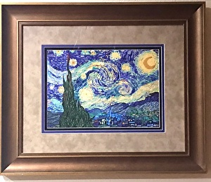
After I left work, an artist friend gave me a Sumi-E book thinking this might be something I could do. Enjoying it but wanting color, I found an online watercolor work at your own pace course in 2019. I fell in love with the beautiful transparency and glow of the medium. I became excited that you could express with paint not just beauty but the feelings you have about a place, person, or thing just by manipulating colors, light, and values. Painting for me is a distraction from pain and disability, and a time of meditation that brings me great joy!
With my website, my works, and my social media presence, I want to highlight how art can be beneficial as a therapy in chronic disease management (based on my experience). I hope my paintings will bring you the same happiness I felt during their creation each time they are viewed. Looking forward is easier now with a purpose, continual learning, community, and painting.
Ed. Note: See links to Marla’s website in the ‘On the Internet’ section at the bottom.

Burney Falls General Store
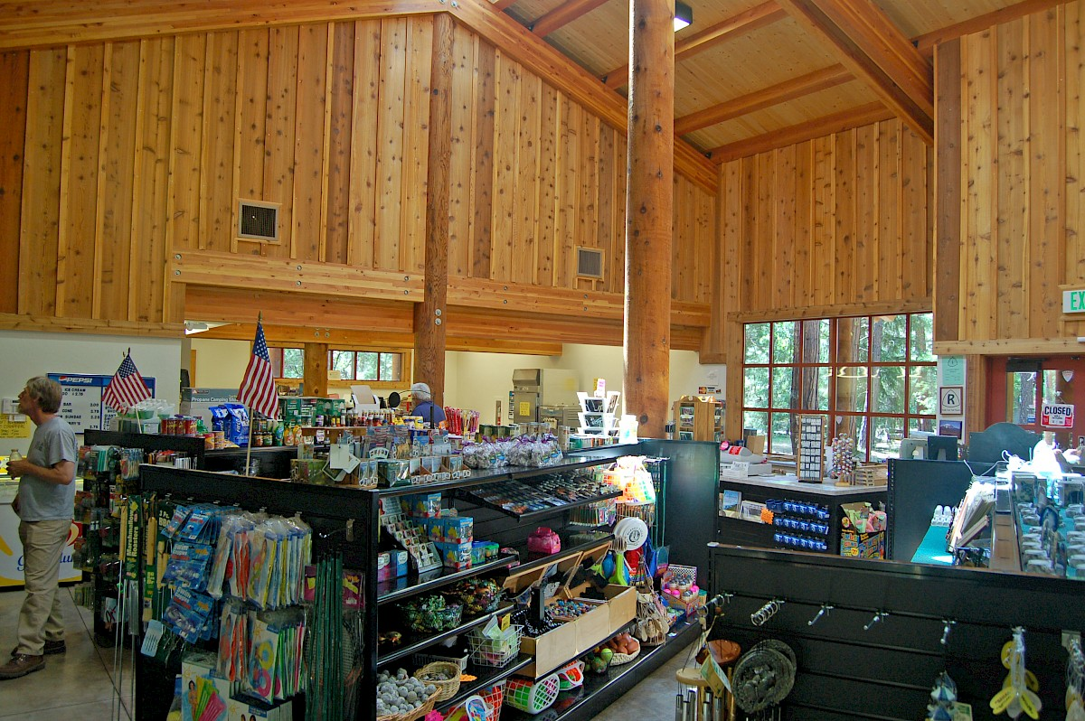
Conveniently located within Burney Falls State Park, the Burney Falls General Store is your go-to stop for essential supplies and quick refreshments. You’ll find a variety of cold drinks, tasty treats, and basic camping necessities—all surrounded by the beauty of the park’s towering pines and tranquil atmosphere. Friendly staff and a rustic setting make it a welcoming stop for campers and day visitors alike.
Ed. Note: See the link to the General Store website in the ‘On the Internet’ section at the end of this newsletter.

Job Openings

MBFIA Bookkeeper
The Association needs a bookkeeper/treasurer to join the Board on a volunteer basis. This is a great way to give back to the community, working with a group of like-minded people who get a kick out of helping to improve three local State parks, including MacArthur-Burney Falls Memorial State Park. Great for a retired person who wants to keep active up to 10 hours a week. Knowledge of Quick Books helpful. Contact Board President Jim Sacson at (530) 513-7102.

Camp Hosts

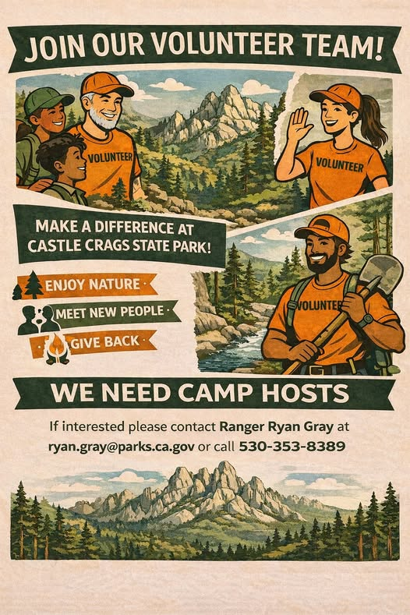
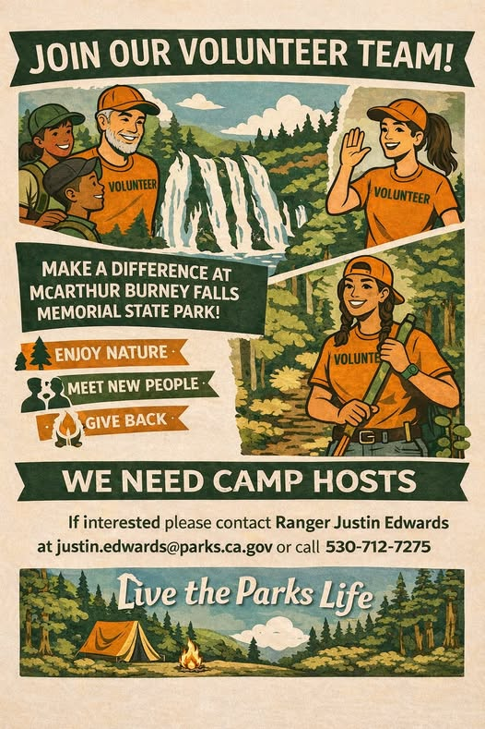
Visitor Services Senior Park Aide
The Visitor Services Senior Park Aide (Seasonal) is expected to work weekends, holidays, and evenings if necessary and assigned days off may vary from month to month. The Visitor Services Senior Park Aide (Seasonal) will perform duties dressed in full State Park uniform.
Primary duties include but are not limited to: Park Aide Lead and administrative duties such as maintaining accountability worksheets, attendance records, and Park Aide schedule, training new Park Aide staff, providing direction and assistance to Park Aide staff, and receptionist duties for the office. The Senior Park Aide (Seasonal) will also
operate the entrance station, greet visitors, and provide information about park conditions, closures, trails, and rules and regulations. In addition, the Senior Park Aide (Seasonal) should be proficient in basic use of a computer and able to check work e-mail account.

Memorial Tables
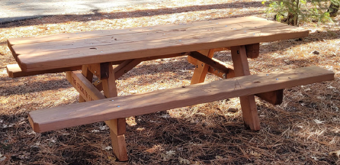
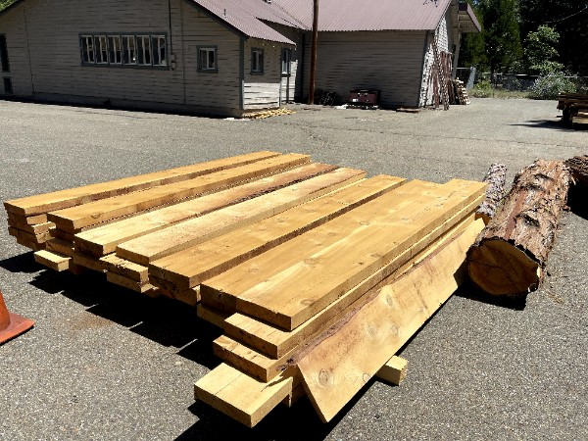
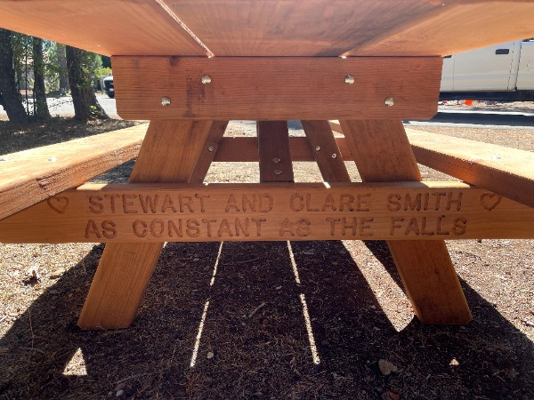
We are thrilled to offer you a limited opportunity to purchase an engraved memorial table to be placed in the Park for years to come! Here's your opportunity to contribute a tax-deductible gift to the Park and to create an everlasting memory of a special time at the park or in honor of a family member or friend, while contributing to the Friends of the Falls at the same time! Contact Bill McSweeney at: calpacker@comcast.net or 415-726-3241 for information and an application!The MBFIA builds memorial tables and places them throughout the parks. They can be purchased for $2800. Each end can have memorial information etched into the bench.

Tribute

A Tribute to Generations of Families Who Vacation At Burney Falls
For over forty years and probably more, families have gathered at McArthur Burney Falls Memorial State Park to spend time together. Grandparents, Uncles & Aunts, Cousins, Moms, Pops, and children camping, swimming, fishing, hiking, cooking, sleeping under the stars, roasting marshmallows, singing, and making strong memories. You may find their names on tables and benches throughout the park in memory of loved ones.
We would like to acknowledge the families that call this park home and have supported its interpretive services for at least the last ten years. The ones we know about are listed below. If you are not on the list, please let us know who you are and how long your family has been trekking to Northern California to spend time at our beautiful park.

Tribute to Families that call McArthur Burney Falls Home
- The Ashby Family – Susan, Bill, Bryan, Leslie & Brayden - 46 years
- The Busalacchi Family – 51years
- The Calkin Family – In Memory of Sandy Stefenoni
- The Case Family & the Kelly’s Wishes Foundation - In Honor of Kelly Case Moulton
- The Coughlin Family – In memory of Rober Vajretti and his Burney Legacy - 45 Years
- The Damato Family – 52 years
- The Doo Family – In honor of Jack & Cathy Doo
- The Garcia Family – In Memory of Dale Berliner - 30 years
- The Germeraad Family – In Honor of Stewart & Clare Smith – 4 generations
- The Gomez Family – In Memory of Sandy Stefenoni - 46 years
- The Gutilla Family- In Honor of Daniel Ries. Our families have been visiting Burney Falls for decades.
- The Hesselroth & Russell families - In memory of Mrs. Pamela Russell and her husband, John, who began vacationing at McArthur Falls in the 1970’s. – 50 Years
- Kamp Kearney – - A family tradition for more than 46 years and keeping the tradition going for 100 more in honor of Tim and Joy Kearney.
- The McKay Family – 52 years
- The Miller Family - 46 years
- Tom & Mary Pilla- Honoring John Roderick McArthur, nephew of Frank McArthur of the McArthur Family, who bequeathed the park to the citizens of California.
- The Stefenoni Family – 46 Years
- The Strickler Family
- The Taube Family
- The Towle Family – In Memory of Tom Garcia – 116 years
- The Van Aken Family – 62 years
- The Vitale Family – In Memory of Scott Lunger – 29 years
- The Wilbur Family – In Memory of Linda Wilbur - 51 years
- The Zwanziger Family – In honor of grandchildren Callen, Kassidy, Kamille and Chase- 60 years
Thank you all for your love and support of this beautiful park.

Contact Infomation
- MBFIA (McArthur-Burney Falls Interactive Association), PO Box 777, Burney 96013, friends@burneyfallspark.org
  - Board President Jim Sacson: jimsacson@gmail.com, (530) 513-7102
  - Webmaster Bob Boyce: webmaster@burneyfallspark.org
  - Tablemaster Bill McSweeney: calpacker@comcast.net
  - Newsletter Editor Tony Otto: tony.otto.frm@gmail.com, (530) 610-2133
- McArthur-Burney Falls Memorial State Park, 24898 CA Hwy 89, Burney, CA 96013,(530) 335-2777
  - Falls Ranger Justin Edwards, justin.edwards@parks.ca.gov, (530) 712-7275
- Burney Falls Visitor’s Center: (530)‌ 335-3171
- Castle Crags State Park, 20022 Castle Creek Road, Castella, CA 96017, https://castlecragspark.org/
  - Crags Ranger: Ryan Gray, ryan.gray@parks.ca.gov, (530) 353-8389

On the Internet

MBFIA (McArthur-Burney Falls Interpretive Association)
https://burneyfallspark.org/
https://www.parks.ca.gov/?page_id=28535
https://www.facebook.com/BurneyFallsPark/
https://burneyfallspark
.networkforgood.com/
https://projects.propublica.org/nonprofits/organizations/680041373

Burney Falls General Store
https://burneyfallshospitality.com/

MacArthur-Burney Memorial State Park
https://www.parks.ca.gov/?
page_id=455

https://en.wikipedia.org/wiki/McArthur
%E2%80%93Burney_Falls_Memorial
_State_Park
https://www.facebook.com/mbfmsp/
https://www.tripadvisor.com/
ShowUserReviews-g32125-d102684-
r240734010-
McArthur_Burney_Falls_Memorial_St
ate_Park-Burney_California.html
https://www.reddit.com/r/
norcalhiking/comments/1l2y6v9/
mcarthur_burney_falls/

Castle Crags State Park
https://www.parks.ca.gov/?
page_id=454
https://castlecragspark.org/
https://en.wikipedia.org/wiki/
Castle_Crags
https://wilderness.net/visit-
wilderness/?ID=103

Ahjumawi Lava Springs State Park
https://www.parks.ca.gov/?
page_id=464
https://www.visitcalifornia.com/
experience/ahjumawi-lava-springs-
state-park/
https://www.shastacascade.com/
account/ahjumawi-lava-springs-state-
park
https://en.wikipedia.org/wiki/
Ahjumawi_Lava_Springs_State_Park

April Featured Artist: Marla Nolan
https://www.rheum2cre8art.com/
https://linktr.ee/rheum2cre8art

Secret San Francisco Article
https://secretsanfrancisco.com/burney-falls-california-eighth-wonder-of-the-world/

